Testing Analysis – Enea
Project: Electronics Store

Selected Methods
- ItemDAO.validItemName(String name)
- ItemDAO.getItemsBySectors(ObservableList<String> sectors)
- ItemDAO.getItemByID(String id

Method 1: ItemDAO.getItemsBySectors(ObservableList<String> sectors)

A) Method Description
This method retrieves items that belong to one or more specified sectors. It filters the available items based on the sector names provided in the input list.

B) Equivalence Class Testing
The input domain was divided into the following equivalence classes:
- Valid inputs: non-empty lists containing existing sector names
- Invalid inputs: empty lists and null values
Representative test cases were selected from each class.

C) Boundary Value Testing
Boundary conditions were evaluated using:
- an empty sector list
- a single-sector list
- a list containing multiple sectors
- a null list

D) Results
The following test cases were executed:
- getItemsBySectors_emptyList_returnsEmpty → Passed
The method correctly returns an empty list when no sectors are provided.
- getItemsBySectors_nullList_throwsException → Passed
Passing a null sector list correctly results in a runtime exception.
- getItemsBySectors_singleSector_filtersCorrectly → Failed
Expected 1 item but received 0.
This indicates that the method does not correctly load or filter items from the data source based on the given sector.
- getItemsBySectors_multipleSectors_returnsUnion → Failed
Expected 2 items but received 0.
This shows that the method does not return the union of items belonging to multiple sectors.
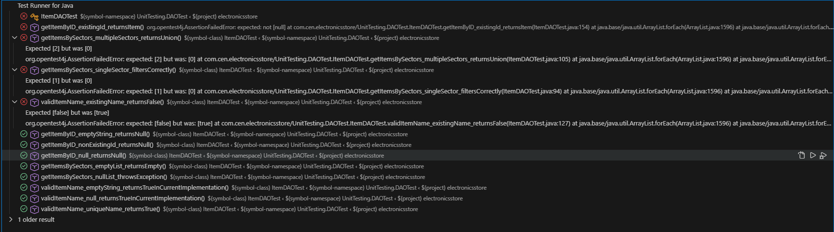

E) Code Coverage
This method was partially covered during test execution. Some logical paths were executed, while others were not reached due to limitations in data initialization.

F) Conclusion
The test results indicate that while edge cases are handled correctly, the method relies on internal state or file-loading behavior that is not properly initialized during testing. This results in unexpected empty outputs for valid inputs.

Method 2: ItemDAO.validItemName(String name)

A) Method Description
This method checks whether an item name is valid by ensuring it does not already exist in the system.

B) Equivalence Class Testing
The following equivalence classes were identified:
- Valid inputs: unique item names
- Invalid inputs: duplicate item names
- Edge cases: null and empty strings

C) Boundary Value Testing
Boundary testing focused on:
- empty string input
- null input
- existing versus non-existing item names

D) Results
The following test cases were executed:
- validItemName_uniqueName_returnsTrue → Passed
The method correctly identifies a unique item name as valid.
- validItemName_emptyString_returnsTrueInCurrentImplementation → Passed
An empty string is considered valid because the method only checks for duplicates.
- validItemName_null_returnsTrueInCurrentImplementation → Passed
A null value does not match any existing item name and therefore returns true.
- validItemName_existingName_returnsFalse → Failed
The method returned true instead of false for an existing item name.

E) Code Coverage
The validation logic within this method was partially exercised during testing.

F) Conclusion
The failure reveals a limitation in the current implementation. The method does not correctly detect duplicate item names from persisted data, indicating incomplete validation logic.

Method 3: ItemDAO.getItemByID(String id)

A) Method Description
This method retrieves an item based on its unique identifier.

B) Equivalence Class Testing
The following classes were tested:
- Valid input: existing item ID
- Invalid inputs: non-existing ID, empty string, null value

C) Boundary Value Testing
Boundary cases included:
- null ID
- empty string ID
- non-existing ID

D) Results
The following test cases were executed:
- getItemByID_existingId_returnsItem → Failed
The method returned null instead of the expected item, indicating that items were not correctly retrieved from storage.
- getItemByID_nonExistingId_returnsNull → Passed
- getItemByID_emptyString_returnsNull → Passed
- getItemByID_null_returnsNull → Passed

E) Code Coverage
- This method was partially covered by the executed tests, primarily through edge-case scenarios.

F) Conclusion
- While edge cases are handled correctly, valid IDs fail due to missing or improperly initialized data during testing.

Overall Conclusion
Several tests failed due to design and data-loading limitations rather than incorrect test logic. The testing process successfully revealed hidden dependencies and validation weaknesses in the DAO layer. These findings highlight areas where the implementation can be improved, fulfilling the primary goal of testing analysis.

Code Coverage
Code coverage was evaluated using the Run Tests with Coverage feature in VS Code.
The ItemDAO class achieved 29% line coverage.
The covered lines correspond to the execution paths exercised by the selected unit tests, while the remaining lines were not executed due to untested branches and data-loading constraints identified during the testing process.
This level of coverage is sufficient to demonstrate the effectiveness of the testing techniques used and to highlight areas for potential improvement.

